
QUALITY ALERT

Customer: ATI Date: March 13, 2023
Die: 15032 Colour: Any
Type of Complaint: ATI REJECTED

Q.A # Q.I.R # CUSTOMER NCR #

Description: ATI REJECT – Sharp corner/brittle material or wall-thickness small causing the interlock to crack between the weather-strip channel.
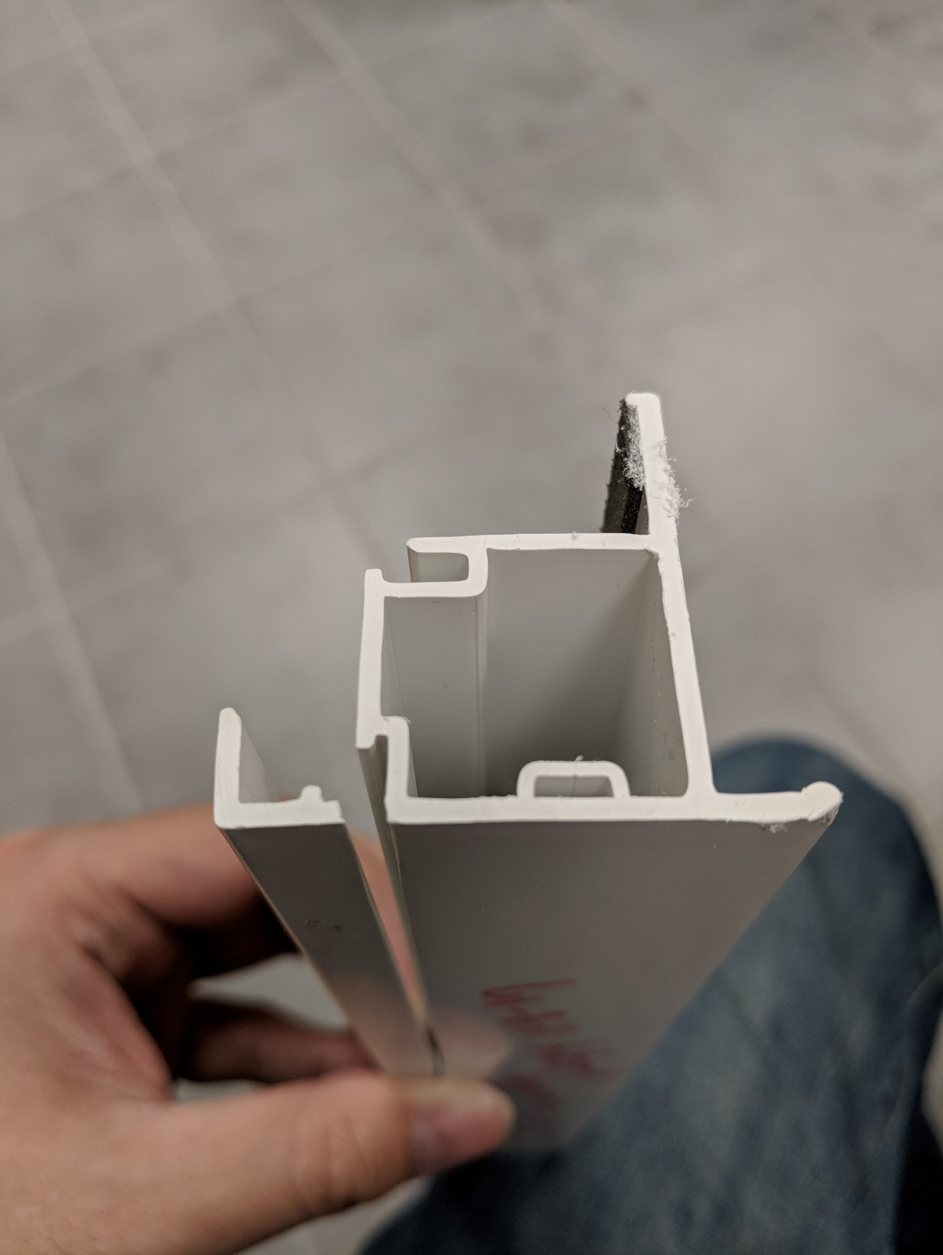
- CHECK WITH PLIER BY PULLING BACK INTERLOCK
- AVOID PUTTING AIR & STRIPS IN THIS AREA MAKING IT WEAK
- MAKE SURE TO CHECK IMPACT
- LOOK FOR ANY SHARP CORNERS
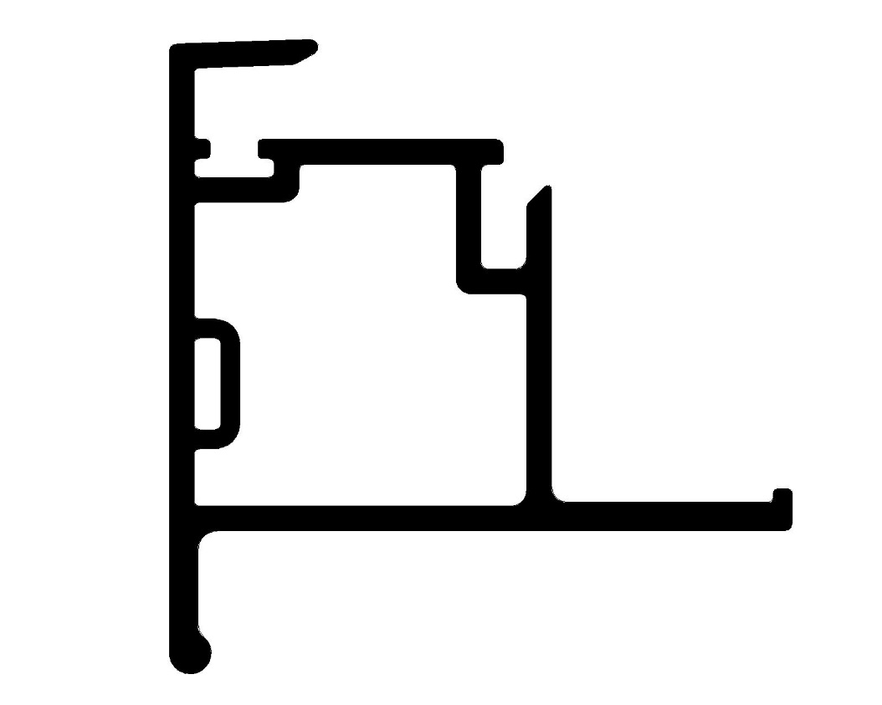

text

le
BY SIGNING BELOW, YOU ACKNOWLEDGE THE PROBLEM ABOVE AND AGREE TO MONITOR THIS ISSUE IN FUTURE PRODUCTION RUNS.
DAY SHIFT |  | AFTERNOON SHIFT |  | NIGHT SHIFT
NAME | SIGNATURE | NAME | SIGNATURE | NAME | SIGNATURE

